**ATAR HUMAN BIOLOGY UNIT 4**

**Task 10: Gene Pools & Evidence for Evolution**

**MARKING KEY**

1. A B **C** D

2. A B C **D**

3. A **B** C D

4. A B C **D**

5. A B **C** D

6. A B C  **D**

7. A B **C** D

8. **A** B C D

9. A B C **D**

10. **A** B C D

**Question 1 (7 marks)**

1. Describe the difference between a gene mutation and a chromosome mutation *(1 mark)*

|  |  |
| --- | --- |
| **Description** | **Mark** |
| Gene mutation – a single gene is affected  Chromosome mutation – lots of genes affected/whole section of chromosome | 1 |
| **TOTAL** | **1** |

1. The major sources of new variations in a gene pool are mutations. Although they can occur in any cell in the body, mutations occurring in only one type of cell will result in changes to allele frequencies in a gene pool. Name the type of cell, and explain how mutations in these types of cells can cause changes in allele frequencies in a gene pool  *(2 marks)*

|  |  |
| --- | --- |
| **Description** | **Mark** |
| Germline Cell/gamete | 1 |
| They can be passed on to the next generation, so can alter allele frequency | 1 |
| **TOTAL** | **2** |

1. Mutations in the human genome can result from a variety of causes. Explain how mutagens can cause mutations, the types of mutations mutagens can produce, and give an example of a mutagen. *(4 marks)*

|  |  |
| --- | --- |
| **Description** | **Mark** |
| Any three of:   * Can resemble proteins and be incorporated into DNA * Can trigger DNA replication errors * Can cause DNA breakages/lengthening * Can block DNA replication/damage DNA structure * Can chemically react with and modify DNA | 1-2 |
| Can cause gene and chromosome mutations/can affect one gene or whole part of chromosome/somatic and germline mutations | 1 |
| Any appropriate mutagen listed (UV rays, X-rays, gamma rays, etc) | 1 |
| **TOTAL** | **4** |

**Question 2 (10 marks)**

1. When different populations of the same species are separated for an extended period of time, they may evolve into different species. Explain the mechanisms underpinning speciation. *(4 marks)*

|  |  |
| --- | --- |
| **Description** | **Mark** |
| Variation - exists in population | 1 |
| Isolation – barrier separates original population/gene pool | 1 |
| Selection – different selection pressures in two environments, so different alleles favoured | 1 |
| Speciation – over time develop into two new species that can’t reproduce with each other | 1 |
| **TOTAL** | **4** |

1. Using your knowledge of Natural Selection, explain why populations that live closer to the equator tend to have much darker skin than populations that live closer to the poles. *(4 marks)*

|  |  |
| --- | --- |
| **Description** | **Mark** |
| Describes strength of UV rays at both locations | 1 |
| Links pale skin and death near equator | 1 |
| Links dark skin and vitamin D deficiency near poles | 1 |
| Those with favoured alleles more likely to survive and pass on allele, causing differences in allele frequencies/phenotype between two locations. | 1 |
| **TOTAL** | **4** |

1. Predict why the Arctic Inuit are able to remain healthy, despite having darker skin in an area that receives little sunlight.  *(2 marks)*

|  |  |
| --- | --- |
| **Description** | **Mark** |
| Vitamin D comes from diet not UV | 1 |
| Doesn’t matter that skin colour/additional melanin limits vitamin D production because of little UV / no selective advantage for pale skin allele | 1 |
| **TOTAL** | **2** |

**Question 3 (8 marks)**

1. Describe the anatomical evidence that supports the understanding that collections of species share a recent common ancestor. *(6 marks)*

|  |  |
| --- | --- |
| **Description** | **Mark** |
| Homologous Structures:   * Homologous structures show that species have a common ancestor * Same/similar structures between species, but perform different function * More similar in structure, more recent common ancestor | 1-3 |
| Embryology:   * Similar structures/embryo shape between different species suggests recent common ancestor/more closely related | 1 |
| Vestigial Organs:   * Body structures in modern species that have limited or no function * If similar to another modern species, suggest that two species share common ancestor | 1-2 |
| **TOTAL** | **6** |

1. Explain the importance of restriction enzymes in regard to finding evidence for evolution *(3 marks)*

|  |  |
| --- | --- |
| **Description** | **Mark** |
| Used to cut genes in DNA at same recognition sites | 1 |
| If done in different species, DNA can then be compared using Gel Electrophoresis | 1 |
| Links back to question – ‘more similarities between DNA, more recent common ancestor’. | 1 |
| **TOTAL** | **3** |

**Question 4 (10 marks)**

The phylogenetic tree below gives basic evolutionary information about the Hominidae family.

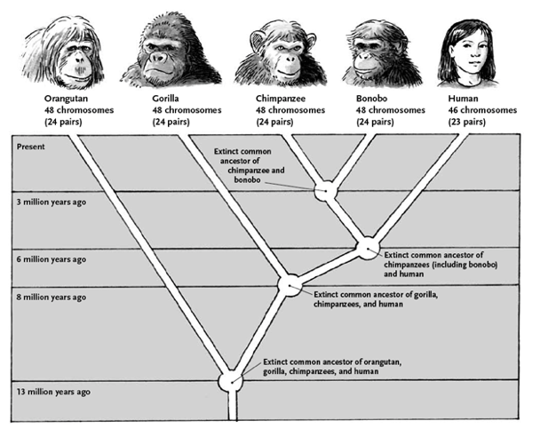

1. Using the information in this phylogenetic tree, which two organisms are most closely related? *(1 mark)*

|  |  |
| --- | --- |
| **Description** | **Mark** |
| Chimpanzee and Bonobo | 1 |
| **TOTAL** | **1** |

1. Explain how scientists might use endogenous retroviruses to develop this phylogenetic tree. *(2 marks)*

|  |  |
| --- | --- |
| **Description** | **Mark** |
| Look at the number of ERV’s the different organisms have in common; more in common, more closely related | 1 |
| Links back to developing the phylogenetic tree –   * Species with more ERV in common are closer together on tree * Look for when new ERVs appear as indicates when split from common ancestor | 1 |
| **TOTAL** | **2** |

1. Explain why scientist use ubiquitous proteins to research the relationships between species. *(2 marks)*

|  |  |
| --- | --- |
| **Description** | **Mark** |
| They are proteins that all species have | 1 |
| The more similarities, the more closely related / the more differences, the longer ago species split. | 1 |
| **TOTAL** | **2** |

1. Comparative studies in biochemistry can be used to provide evidence for evolution. Describe what is meant by comparative mitochondrial DNA studies and explain how they could be used to provide evidence for evolution. *(4 marks)*

|  |  |
| --- | --- |
| **Description** | **Mark** |
| Comparing the mitochondrial DNA between species | 1 |
| mtDNA rapidly mutates, so large differences between different species | 1 |
| Only really useful for comparing recent ancestor, e.g. humans and other primates | 1 |
| The more similarities between species, the more closely related / the more difference, the longer ago species split | 1 |
| **TOTAL** | **4** |

**Extended Response (10 marks)**

In Jurassic Park, researchers discovered a blood-filled mosquito that had been preserved in amber. Assuming that this mosquito only contained blood from a single organism, explain how the researchers could amplify the amount of DNA available to test, and how they could then determine the order of nucleotides in the DNA from the blood.

|  |  |
| --- | --- |
| **Description** | **Mark** |
| **How researcher amplify DNA** |  |
| Amplify amount of DNA using PCR | 1 |
| Multiple cycles so lots of copies made | 1 |
| Three stages named (denature, anneal, elongate) | 1 |
| Three stages described (refers to temperature, Taq polymerase and nucleotides) | 1 |
| **Determine order of nucleotides** |  |
| Any four of the following:   * Amplified DNA denatured * Anneal primer * Sample put into four containers with DNA polymerase and all four deoxynucleotides * Each container receives only one type of dideoxynucleotide (A, C, T or G) * DNA Polymerase builds complementary strand with dideoxynucleotides * Dideoxynucleotide missing hydroxyl group, so strand terminates when one is added * Multiple cycles so lots of DNA fragments of different lengths made | 1-5 |
| **Linking back to question** |  |
| Gel electrophoresis used to read the sequence of nucleotides in DNA sample | 1 |
| **TOTAL** | **10** |

‘